Events programme July - September 201

In the following programme you will find a number of ways in which you can get involved in Lewisham’s rivers management. Sessions are run by
a number of groups who offer different opportunities, from local ‘Friends’ to Thames21 and the Creekside Discovery Centre so hopefully there is
something for everyone! For further information on related events, please check out the Lewisham’s nature conservation blog, which is updated regularly. www.natureconservationlewisham.co.uk

Glendale Grounds Management and London Borough of Lewisham

Glendale Grounds Management are the Council’s park contractors. As part of their commitment to nature conservation, they offer a number of volunteering opportunities. As well as working in partnership with the river bank management programme, they also hold a number of river related community events.

River Bankside Volunteering - see how you could become fitter and healthier by doing something positive for you and for your local rivers

This program is run in partnership between London Borough of Lewisham and Glendale Grounds Management. It is a project that offers opportunities for you to improve your fitness by taking part in practical river bankside management related activities in a local river. It is a great way to visit parts of your local rivers that you may not know about and lend a helping hand to improve water habitats for wildlife within the Borough. The session is free, fun and no experience is needed but please note that although we try to cater for a range of abilities participants do have to be reasonably physically fit to undertake most of the tasks involved. We therefore reserve the right to judge if this project offers you the support that you may require.

We provide tools and refreshments and have a mid-session tea break.

For more information, please contact:

Judith Simmons- Glendale nature conservation officer
Office: 0208 852 9167 Mobile: 07919548324 Email: judith.simmons@glendale-services.co.uk



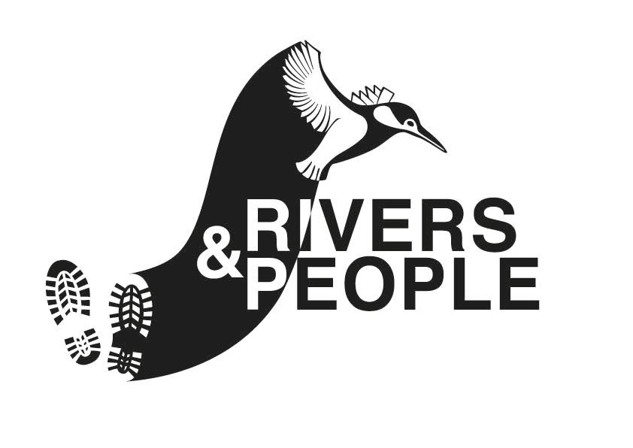

ALL YOU NEED TO KNOW:
- Before attending your first session we ask that you fill out a registration form so that we are aware of any medical issues that may prevent you from carrying out certain tasks and so we have your next of kin details. If you have not done so already, please contact us, and we will be happy to send you one.
- Sessions run between 11am-2pm with a mid-session tea break, we provide tea/coffee so please bring snack/lunch if required.
- Unless otherwise stated please contact Judith Simmons before a project to let me know that you are coming. This is especially important if this is your first time with us or you have not been for a while, we wouldn’t want you turning up to the wrong place looking for us and also, so we can provide you the right size waders e.t.c.
- Our meeting points at sites can vary, so please make sure that you check the details carefully, we don’t want to lose you!
- While we try to find a variety of tasks for the sessions, this isn’t always possible and some tasks may not be suitable for everyone. Therefore, please check the task for the day to assess its suitability for you. If in doubt, please call and we would be happy to discuss this further.
- Please be at the meeting point on time because often the work destination can be up to a 10-15 minute walk from where we meet - we wouldn’t want you wondering around for ages looking for us!
- If you have any questions please feel free to contact Judith, who will be happy to help.
Please note that sessions are subject to change. If in doubt please call the named organiser who will be able to confirm the details.
Toilets: | Not all sites have toilets; look out for the symbols next to each site.
We will provide: | All tools, gloves and training. Tea/coffee will be available at the break
You will need: | Appropriate clothing for the weather and task. Sturdy boots, preferably with steel toe caps. Please no sandals!
 | Lunch if required for the break
 | Extra water, especially on hot days would be advisable
 | Any medication you need, i.e. inhaler, antihistamine etc.
Tetanus: | Please make sure your tetanus inoculation is up to date.

PLEASE CHECK WITH THE EVENT ORGANISER BEFORE COMING TO A SESSION AS THEY MAYBE SUBJECT TO CHANGE.
WE CANNOT TAKE RESPONSIBILITY FOR EVENTS THAT ARE NOT ORGANISED BY US.

Date & Time | Location & Organiser | Activity | Site/directions/ meeting point | Local transport | Contact/Booking Information
Tuesday 04/07/2017  11am-2pm | Cornmill Gardens   | - River bank vegetation management  - General litter clearance  - Eradication of invasive  - Clearing the board walks from weeds | Meet at Cornmill Gardens by the playground. | 1. Train: Lewisham Station or/& Lewisham DLR  2. Bus: 436, 136, 47, 225, 21, 75 & 185  3. No free parking | Judith Simmons  020 8318 3986  judith.simmons@glendale-services.co.uk
Tuesday 11/07/2017  11am-2pm | Chinbrook Meadows | - Clearing nettles/brambles from the river banks.  - General litter clearance  - Eradication of invasive species  - Pond clearance | Meet by the Park Ranger’s Office, near the entrance on Amblecote Road. | 1. Nearest Rail Station, Grove Park.  2. Buses include, 124, 126 & 273 which serve Chinbrook Road  3. Car park on site. | Judith Simmons  020 8318 3986  judith.simmons@glendale-services.co.uk
Tuesday 18/07/2017  11am-2pm | Ladywell North Fields | - River bank vegetation management  - General rubbish clearance  - Eradication of invasive Pond work | Ladywell Road. Meet in Ladywell Fields near the TEN THOUSAND HANDS Cafe. | 1. Closest rail stations Ladywell Station.  2. Buses 484, 122 or P4.  No free car parking. | Judith Simmons  020 8318 3986  judith.simmons@glendale-services.co.uk
Tuesday  25/07/2017  11am –2pm | Manor Park | - General litter/rubbish clearance  - Eradication of invasive species Clearing the seasonal pond | Entrance on Manor Park Road. SE13  Meet by the Café building.  (Please note that this event is at Manor Park Not Manor House Gardens) | Nearest train Hither Station.  2. Buses ; 273 (manor Park) and Buses serving Lee High Road.  No free parking until after 12pm. | Judith Simmons  020 8318 3986  judith.simmons@glendale-services.co.uk
Date & Time | Location & Organiser | Activity | Site/directions/ meeting point | Local transport | Contact/Booking Information
Tuesday 01/08/2017  11am-2pm | NO SESSION
Tuesday  08/08/2017  11am-2pm | Brookmill Park | - General litter/rubbish clearance  - Eradication of invasive | Meet on Brookmill Road.  By park keeper’s office building. | 1. Train: St Johns, Deptford/Lewisham little further away.  2. DLR: Elverson Rd  3. Buses 47 or 225.  4. Parking: on side streets.  Limited parking on streets nearby. | Judith Simmons  020 8318 3986  judith.simmons@glendale-services.co.uk
Tuesday 15/08/2017  11am-2pm | Ladywell North Fields | - River bank vegetation management  - General litter clearance  - Eradication of invasive species  - Pond work | Ladywell Road. Meet in Ladywell Fields near the TEN THOUSAND HANDS Cafe. | 1. Closest rail stations Ladywell Station.  2. Buses 484, 122 or P4.  No free car parking. | Judith Simmons  020 8318 3986  judith.simmons@glendale-services.co.uk
Tuesday 22/08/2017  11am-2pm | Cornmill Gardens | - River bank vegetation management  - General litter clearance  - Eradication of invasive species – where present.  - Clearing the board walks from weeds | Meet at Cornmill Gardens by the playground. | 1. Train: Lewisham Station or/& Lewisham DLR  2. Bus: 436, 136, 47, 225, 21, 75 & 185  3. No free parking | Judith Simmons  020 8318 3986  judith.simmons@glendale-services.co.uk
Date & Time | Location & Organiser | Activity | Site/directions/ meeting point | Local transport | Contact/Booking Information
Tuesday 29/08/2017 | NO SESSION
Tuesday  05/09/2017  11am-2pm | Chinbrook Meadows | - Clearing nettles/brambles from the river banks.  - General litter clearance  - Pond clearance | Meet by the Park Ranger’s Office, near the entrance on Amblecote Road. | 1. Rail Station: Grove Park.  2. Buses include, 124, 126 & 273 Chinbrook Road  3. Car park on site. | Judith Simmons  020 8318 3986  judith.simmons@glendale-services.co.uk
Tuesday 12/09/2017  11am-2pm | Manor Park | - General litter clearance  - Eradication of invasive species Clearing the seasonal pond | Entrance on Manor Park Road. SE13  Meet by the Café building.  (Please note that this event is at Manor Park Not Manor House Gardens) | 1. Nearest train Hither Green  2. Buses: 273 (Manor Park) & Buses serving Lee High Road.  No free parking until after 12pm. | Judith Simmons  020 8318 3986  judith.simmons@glendale-services.co.uk
Tuesday 19/09/2017  11am-2pm | Ladywell North Fields | - River bank vegetation management  - Litter clearance  - Eradication of invasive species  - Pond work | Ladywell Road. Meet in Ladywell Fields near the TEN THOUSAND HANDS Cafe. | 1. Closest rail station: Ladywell  2. Buses 484, 122 or P4.  No free car parking. | Judith Simmons  020 8318 3986  judith.simmons@glendale-services.co.uk
Tuesday 26/09/2017  11am-2pm | Ladywell North Fields | - River bank vegetation management  - General rubbish clearance  - Eradication of invasive species  - Pond work | Ladywell Road. Meet in Ladywell Fields near the TEN THOUSAND HANDS Cafe. | 1. Closest rail stations Ladywell  2. Buses 484, 122 or P4.  No free car parking. | Judith Simmons  020 8318 3986  judith.simmons@glendale-services.co.uk

